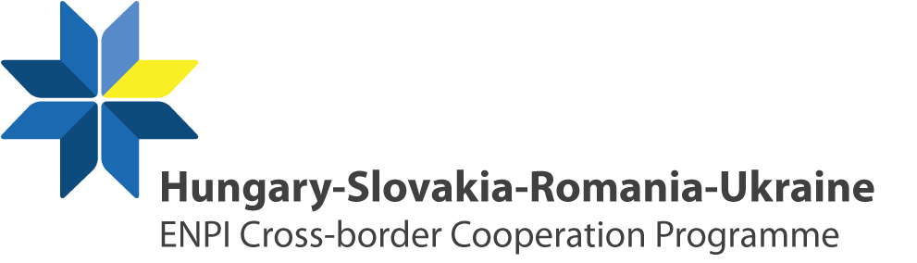

Kick-off conference
of the
Hungary-Slovakia-Romania-Ukraine
ENPI Cross-border Cooperation Programme 2007-2013

23 July 2009, Mukachevo

PRELIMINARY AGENDA

Venue: Mukachevo, Ukraine
“Star” Hotel
Mira sg. 10-12,

11:00 – 11:30 | Registration of the participants
11:30 – 12.50 | Welcoming speeches
 | Presentations
12:50 – 13:00 | Presentation “Programme content”
13:00 – 14:30 | Press conference\Lunch
14:30 – 14:45 | Presentation from the Regional Branch of the Ukrainian National Institute for the Strategic Studies in Uzhgorod
14:45 – 15:45 | Experiences from the Neighbourhood Programmes  Project presentations
15:45 – 15:55 | Presentation “First call for proposals”
15:55 – 16:00 | Conclusions

